October 21:- Work is due to commence on the conversion of numbers 1 - 7 Adam Court. This is estimated to last until June 2022. During this time, and with the exception of disabled candidates, we will be unable to offer parking inside Adam Court.
​If you are disabled, please call 07807 778813 to arrange access.

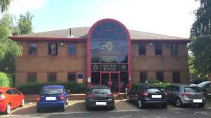
dSefton House
We are located off the Newark Road, Eastern Industry, just south of the junction with Vicarage Farm Road. Adam Court is the group of red brick buildings, opposite the main Eagle Foods depot.
Turn into Adam Court and take the left fork down to the end of the road. Sefton House is the last building on the right. There is limited free parking on-site but additional free parking along stretches of Newark Road in front of Adam Court (where white van shown below) and on the adjacent Vicarage Farm Road.
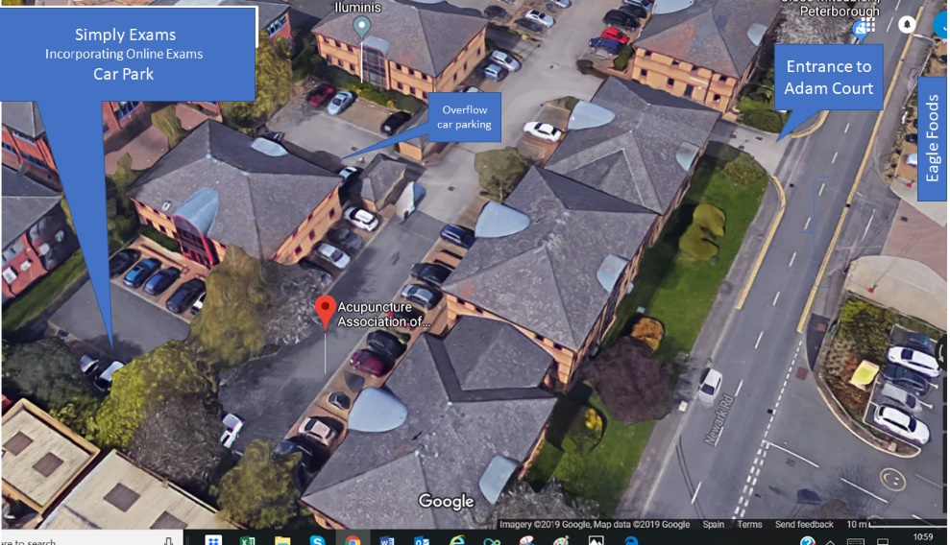

From North, West and South. From the west join the A1(M) to Fletton Pkwy/A1139 in Peterborough. From the north or south take exit 17 from A1(M) onto Fletton Pkwy/A1139.
Continue in the direction of Wisbech. At junction 5 take the exit towards the City Centre. At the roundabout, take the 4th exit onto Boongate. At the second roundabout take the 2nd exit left onto Newark Road. Go through the next roundabout at the junction with Padholme Road East. Adam Court is to the left.

From Central Peterborough:- From the Queensgate/Crescent Bridge roundabout take the exit onto the A15 travelling to the south of the City Centre. At the next roundabout take the 1st exit onto Bishop’s Road. At the mini-roundabout take the 2nd exit onto Fengate. Continue along Fengate until the 2nd roundabout (approximately ½ mile) then take the left into Boongate. At the next roundabout take the 4th exit onto Newark Road. Go through the next roundabout at the junction with Padholme Road East. Adam Court is to the left.

\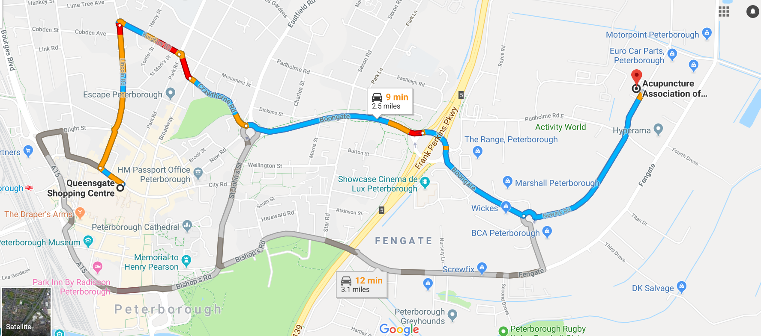

From our Norwich and East Anglia:- . Take the A47 to A1139 in Peterborough. Continue on the A1139 towards Eastern Industry into Parnwell Way and Edgerley Drain Road.
At the junction of Edgerley Drain Road and Vicarage Farm Road , take the turning right into with Vicarage Farm Road . At the next mini-roundabout turn left in Newark Road and continue for approximately 150 metres down the Newark Road. Adam Court is to the right.

